Post-Construction Stormwater Guide
and Check List for Stormwater Compliance

This Inspection Form is based on EPA’s Draft Checklists Developed for EPA’s Post-Construction Stormwater Guidance: Maintenance Checklists
Rev. February 2020
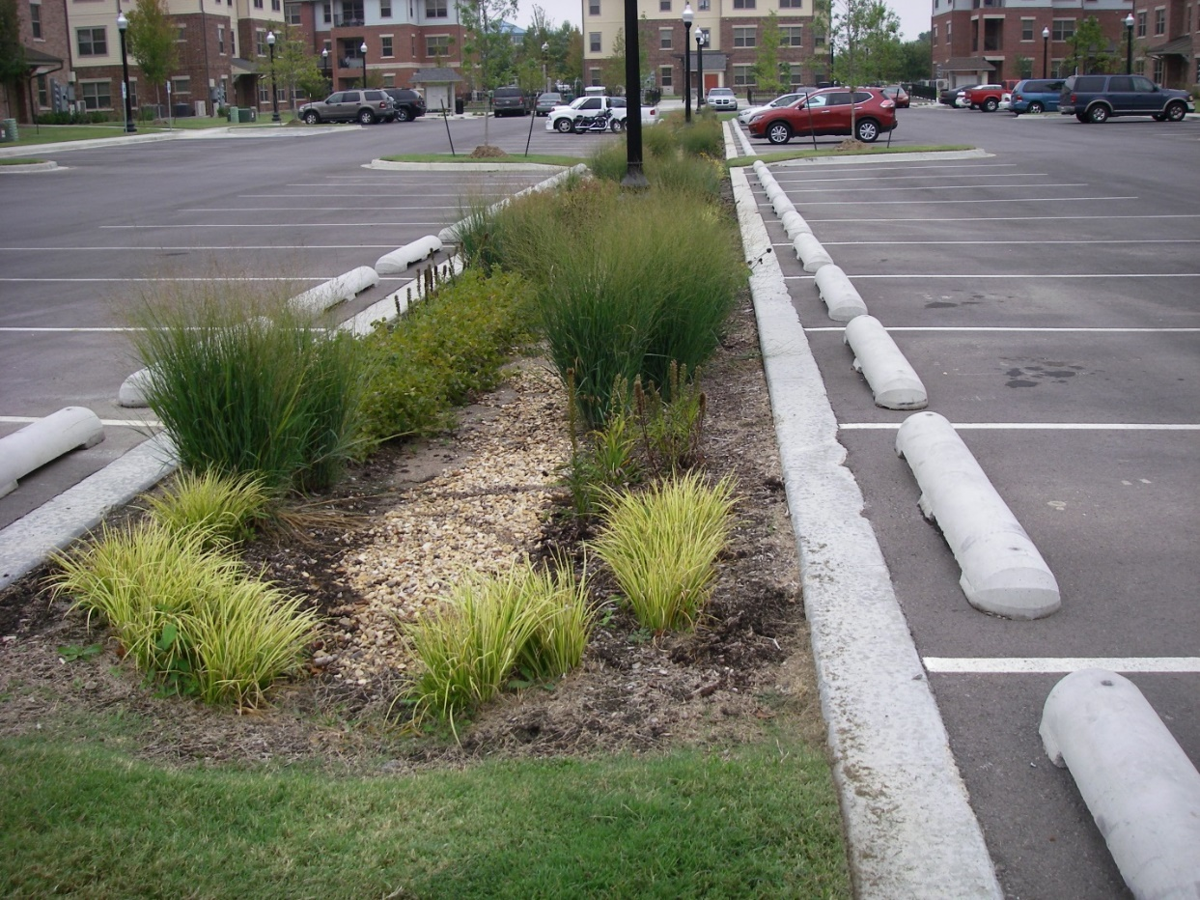
INCOG
2 West Second Street
Suite 800
Tulsa, OK 74103
This document was developed under a FY-16 EPA grant. Upon EPA approval, GCSA notations were added for distribution to INCOG’s GCSA Members.
This guide was developed to assist developers, builders, construction site personnel and stormwater professionals understand stormwater requirements and formatted to be used as an inspection sheet to monitor compliance. Be aware, specific requirements vary according to state, county and municipal regulations. As a result, the best management practices (BMP) mentioned here will be generally accepted as good practice in most localities. This should be considered a living document that is updated as conditions and requirements change and customized to meet local needs. Where detailed information is included, refer to your permit or regulatory agency to ensure it is pertinent to your situation.

A Stormwater Guide for Post-Construction Site Inspections
This post-construction guide is an example of a post-construction checklist that Phase II Stormwater municipalities can build upon as they develop their own checklist. The categories, items and ideas used are from EPA’s “Draft Checklists developed for EPA’s Post-Construction Stormwater Guidance: Maintenance Checklists”. An understanding of post-construction stormwater runoff issues will enable municipalities to be pro-active and design projects that will have minimal long term stormwater issues and problems. This should be considered a living document and adjusted as needs and conditions change.
Site Information For Stormwater Ponds and Wetlands
Site ID: |  | Date & Time:
Street Location: | GPS Coordinates:
Inspector Name: | Inspector Title:
Inspector Contact Information:
Phone Number(s): Email:
Mailing Address:
Party Responsible for Maintenance:

Stormwater Ponds and Wetlands Maintenance Inspection Checklist
Type of stormwater pond or wetland (check all that apply):
Permanent Pool Shallow Wetland Micro pool
Extended detention
Infiltrates into groundwater
Pond with some wetland plantings
Multiple pond system
Type of wetland: No emergent vegetation Emergent vegetation Forested
Type of pretreatment facility: Sediment forebay Grass filter strip Other None

Contributing Drainage Area To Ponds and Wetlands
0 = Good condition. Well maintained, no action required.
1 = Moderate condition. Adequately maintained, routine maintenance needed.
2 = Degraded condition. Poorly maintained, routine maintenance and repair needed.
3 = Serious condition. Immediate need for repair or replacement.
Concerns | Rating | Comments
Excessive trash and debris present | 0 1 2 3 NA
Bare or exposed soil present | 0 1 2 3 NA
Evidence of erosion | 0 1 2 3 NA
Excessive landscape waste and yard clippings | 0 1 2 3 NA

Pretreatment for Ponds and Wetlands
0 = Good condition. Well maintained, no action required.
1 = Moderate condition. Adequately maintained, routine maintenance needed.
2 = Degraded condition. Poorly maintained, routine maintenance and repair needed.
3 = Serious condition. Immediate need for repair or replacement.
Concern | Rating | Comments
Maintenance access to pretreatment facility | 0 1 2 3 NA
Excessive trash and debris present | 0 1 2 3 NA
Excessive sediment accumulation | 0 1 2 3 NA
Evidence of clogging | 0 1 2 3 NA
Dead vegetation and/or exposed soil | 0 1 2 3 NA
Evidence of erosion | 0 1 2 3 NA

Inlets to Ponds and Wetlands
0 = Good condition. Well maintained, no action required.
1 = Moderate condition. Adequately maintained, routine maintenance needed.
2 = Degraded condition. Poorly maintained, routine maintenance and repair needed.
3 = Serious condition. Immediate need for repair or replacement.
Concern | Rating | Comments
Inlets provide stable conveyance into facility | 0 1 2 3 NA
Excessive trash/debris/sediment accumulation at inlet | 0 1 2 3 NA
Evidence of erosion at/around inlet | 0 1 2 3 NA

Facility (Ponds and Wetlands)
0 = Good condition. Well maintained, no action required.
1 = Moderate condition. Adequately maintained, routine maintenance needed.
2 = Degraded condition. Poorly maintained, routine maintenance and repair needed.
3 = Serious condition. Immediate need for repair or replacement.
Concern | Rating | Comments
Maintenance access to facility | 0 1 2 3 NA
Sediment accumulation  Bathymetric study recommended:  Yes No | 0 1 2 3 NA
Abnormally high or low water levels  If yes, cause: | 0 1 2 3 NA
Evidence of pollution/Hotspot runoff  If yes, cause: | 0 1 2 3 NA
Berms and embankments | 0 1 2 3 NA
- Cracking, bulging or sloughing | 0 1 2 3 NA
- Soft spots or sinkholes | 0 1 2 3 NA
- Evidence of erosion | 0 1 2 3 NA
- Evidence of animal burrows | 0 1 2 3 NA
- Presence of woody vegetation | 0 1 2 3 NA
Riser/outlet  Type of riser: | 0 1 2 3 NA
- Maintenance access to riser | 0 1 2 3 NA
- Structural condition of riser | 0 1 2 3 NA
- Condition of joints | 0 1 2 3 NA
- Trash/debris accumulation | 0 1 2 3 NA
Low flow orifice | 0 1 2 3 NA
- Trash/debris accumulation | 0 1 2 3 NA
- Adjustable control valve accessible and operational | 0 1 2 3 NA
Pond drain (underdrain ) system | 0 1 2 3 NA
- Broken | 0 1 2 3 NA
- Clogged | 0 1 2 3 NA
- Adjustable control valve accessible and operational | 0 1 2 3 NA

Facility (Ponds and Wetlands) Continued
0 = Good condition. Well maintained, no action required.
1 = Moderate condition. Adequately maintained, routine maintenance needed.
2 = Degraded condition. Poorly maintained, routine maintenance and repair needed.
3 = Serious condition. Immediate need for repair or replacement.
Concern | Rating | Comments
Vegetation | 0 1 2 3 NA
- Plant composition consistent with approved plans | 0 1 2 3 NA
- Presence of invasive species/weeds | 0 1 2 3 NA
- Dead vegetation/exposed soil | 0 1 2 3 NA
- Reinforcement planting recommended | 0 1 2 3 NA

Outlets (Ponds and Wetlands)
0 = Good condition. Well maintained, no action required.
1 = Moderate condition. Adequately maintained, routine maintenance needed.
2 = Degraded condition. Poorly maintained, routine maintenance and repair needed.
3 = Serious condition. Immediate need for repair or replacement.
Concern | Rating | Comments
Outlets provide stable conveyance out of the facility | 0 1 2 3 NA
Excessive trash/debris/sediment accumulation at outlet | 0 1 2 3 NA
Evidence of erosion at or around outlet | 0 1 2 3 NA

Miscellaneous (Ponds and Wetlands)
0 = Good condition. Well maintained, no action required.
1 = Moderate condition. Adequately maintained, routine maintenance needed.
2 = Degraded condition. Poorly maintained, routine maintenance and repair needed.
3 = Serious condition. Immediate need for repair or replacement.
Concern | Rating | Comments
Complaints from local residents | 0 1 2 3 NA
Mosquito proliferation | 0 1 2 3 NA
Encroachment on facility or easement by buildings or other structures | 0 1 2 3 NA
Adequate safety signage | 0 1 2 3 NA

Inspector’s summary (attach photos): ___________________________________________________________________________________________________________________________________________________________________________________________________________________________________________________________________________________________________________________________________________________________________________________________________________________________________________________________________________________________________________________________________________________________________________________________________________________

Site Information For Infiltration/Filtration/Bioretention Facility
Site ID: |  | Date & Time:
Street Location: | GPS Coordinates:
Inspector Name: | Inspector Title:
Inspector Contact Information:
Phone Number(s): Email:
Mailing Address:
Party Responsible for Maintenance:

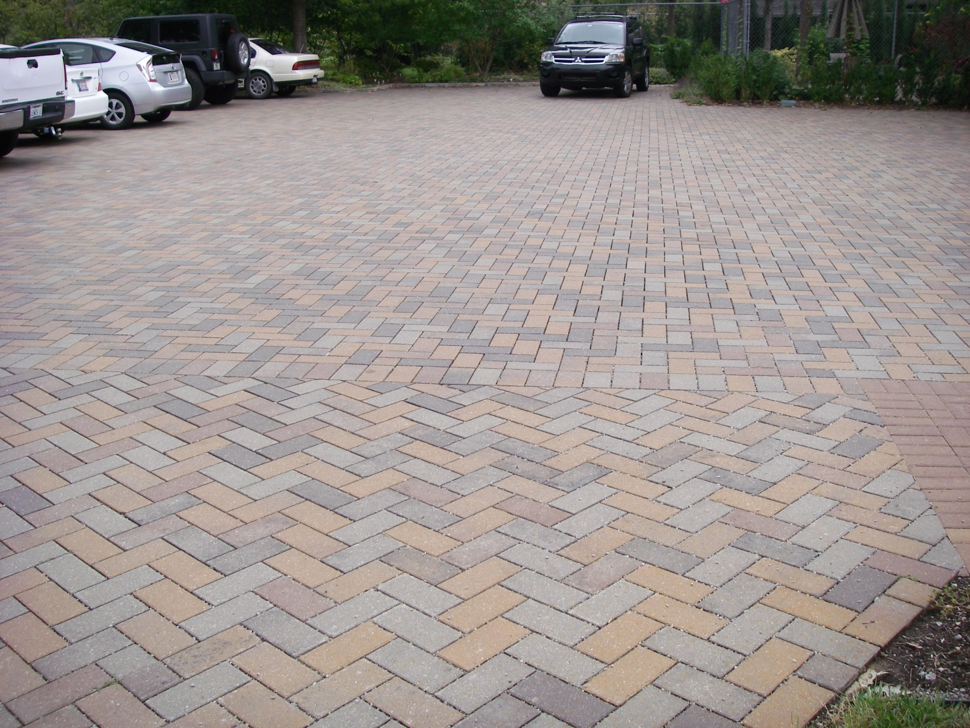

Infiltration/Filtration/Bioretention Facility
Concern | Type | Comments
Type of facility (Check all that apply)
- Infiltration
- Filtration
- Bioretention
- Extended detention
Facility location
- Surface
- Underground
Filtration media
- No filtration media (dry well)
- Sand
- Bioretention soil
- Peat
- Other
Hydraulic configuration
- On-line facility
- Off-line facility
Type of pretreatment facility
- Sediment forebay (above ground)
- Sedimentation chamber
- Grass channel
- Plunge pool
- other

Contributing Drainage Area To Infiltration/Filtration/Bioretention
0 = Good condition. Well maintained, no action required.
1 = Moderate condition. Adequately maintained, routine maintenance needed.
2 = Degraded condition. Poorly maintained, routine maintenance and repair needed.
3 = Serious condition. Immediate need for repair or replacement.
Concerns | Rating | Comments
Excessive trash and debris present | 0 1 2 3 NA
Bare or exposed soil present | 0 1 2 3 NA
Evidence of erosion | 0 1 2 3 NA
Excessive landscape waste and yard clippings | 0 1 2 3 NA
Impermeable surface (e.g. pavement, roof) | 0 1 2 3 NA

Pretreatment To Infiltration/Filtration/Bioretention Area
0 = Good condition. Well maintained, no action required.
1 = Moderate condition. Adequately maintained, routine maintenance needed.
2 = Degraded condition. Poorly maintained, routine maintenance and repair needed.
3 = Serious condition. Immediate need for repair or replacement.
Concern | Rating | Comments
Maintenance access to pretreatment facility | 0 1 2 3 NA
Excessive trash and debris present | 0 1 2 3 NA
Evidence of standing water
- Ponding
- Noticeable odors
- Water stains
- Presence of algae or floating aquatic vegetation
Evidence of clogging | 0 1 2 3 NA
Dead vegetation and/or exposed soil | 0 1 2 3 NA
Evidence of erosion | 0 1 2 3 NA

Inlets To Infiltration/Filtration/Bioretention Area
0 = Good condition. Well maintained, no action required.
1 = Moderate condition. Adequately maintained, routine maintenance needed.
2 = Degraded condition. Poorly maintained, routine maintenance and repair needed.
3 = Serious condition. Immediate need for repair or replacement.
Concern | Rating | Comments
Inlets provide stable conveyance into facility | 0 1 2 3 NA
Excessive trash/debris/sediment accumulation at inlet | 0 1 2 3 NA
Evidence of erosion at/around inlet | 0 1 2 3 NA

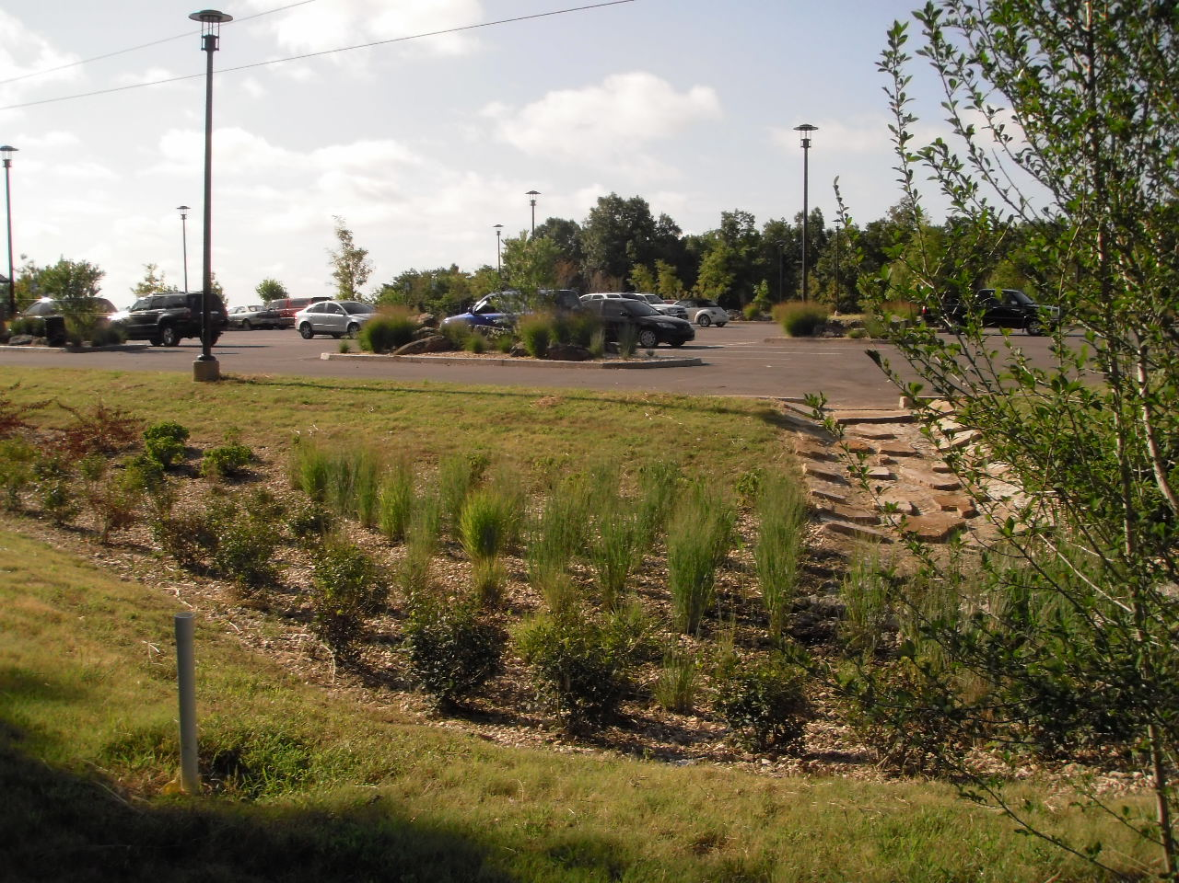

Facility (Infiltration/Filtration/Bioretention)
0 = Good condition. Well maintained, no action required.
1 = Moderate condition. Adequately maintained, routine maintenance needed.
2 = Degraded condition. Poorly maintained, routine maintenance and repair needed.
3 = Serious condition. Immediate need for repair or replacement.
Concern | Rating | Comments
Maintenance access to facility | 0 1 2 3 NA
Condition of structural components | 0 1 2 3 NA
Condition of hydraulic control components | 0 1 2 3 NA
Excessive trash/debris/sediment | 0 1 2 3 NA
Evidence of erosion | 0 1 2 3 NA
Evidence of oil/chemical accumulation | 0 1 2 3 NA
Evidence of standing water | 0 1 2 3 NA
- Ponding
- Noticeable odors
- Water stains
- Presence of algae or floating aquatic vegetation
Underdrain system (if equipped) | 0 1 2 3 NA
- Broken
- Clogged
Vegetation | 0 1 2 3 NA
- Plant composition consistent with approved plans | 0 1 2 3 NA
- Presence of invasive species/weeds | 0 1 2 3 NA
- Dead vegetation/exposed soil | 0 1 2 3 NA
- Reinforcement planting recommended

Outlets For Infiltration/Filtration/Bioretention Area
0 = Good condition. Well maintained, no action required.
1 = Moderate condition. Adequately maintained, routine maintenance needed.
2 = Degraded condition. Poorly maintained, routine maintenance and repair needed.
3 = Serious condition. Immediate need for repair or replacement.
Concern | Rating | Comments
Outlets provide stable conveyance out of the facility | 0 1 2 3 NA
Excessive trash/debris/sediment accumulation at outlet | 0 1 2 3 NA
Evidence of erosion at or around outlet | 0 1 2 3 NA

Miscellaneous For Infiltration/Filtration/Bioretention
0 = Good condition. Well maintained, no action required.
1 = Moderate condition. Adequately maintained, routine maintenance needed.
2 = Degraded condition. Poorly maintained, routine maintenance and repair needed.
3 = Serious condition. Immediate need for repair or replacement.
Concern | Rating | Comments
Complaints from local residents | 0 1 2 3 NA
Mosquito proliferation | 0 1 2 3 NA
Encroachment on facility or easement by buildings or other structures | 0 1 2 3 NA
Adequate safety signage | 0 1 2 3 NA

Inspector’s summary (attach photos): ___________________________________________________________________________________________________________________________________________________________________________________________________________________________________________________________________________________________________________________________________________________________________________________________________________________________________________________________________________________________________________________________________________________________________________________________________________________

Site Information For Open Channel Maintenance
Site ID: |  | Date & Time:
Street Location: | GPS Coordinates:
Inspector Name: | Inspector Title:
Inspector Contact Information:
Phone Number(s): Email:
Mailing Address:
Party Responsible for Maintenance:

Open Channel Maintenance
Concern | Type | Comments
Type of open channel system
- Dry swale
- Wet swale
- Other
Type of pretreatment facility
- Sediment forebay
- Check dam
- Grass filter strip
- Other

Contributing Drainage Area To Open Channel
0 = Good condition. Well maintained, no action required.
1 = Moderate condition. Adequately maintained, routine maintenance needed.
2 = Degraded condition. Poorly maintained, routine maintenance and repair needed.
3 = Serious condition. Immediate need for repair or replacement.
Concerns | Rating | Comments
Excessive trash and debris present | 0 1 2 3 NA
Bare or exposed soil present | 0 1 2 3 NA
Evidence of erosion | 0 1 2 3 NA
Excessive landscape waste and yard clippings | 0 1 2 3 NA

Pretreatment For Open Channel
0 = Good condition. Well maintained, no action required.
1 = Moderate condition. Adequately maintained, routine maintenance needed.
2 = Degraded condition. Poorly maintained, routine maintenance and repair needed.
3 = Serious condition. Immediate need for repair or replacement.
Concern | Rating | Comments
Maintenance access to pretreatment features | 0 1 2 3 NA
Excessive trash and debris present | 0 1 2 3 NA
Evidence of clogging | 0 1 2 3 NA
Dead vegetation and/or exposed soil | 0 1 2 3 NA
Evidence of erosion | 0 1 2 3 NA

Inlets To Open Channel
0 = Good condition. Well maintained, no action required.
1 = Moderate condition. Adequately maintained, routine maintenance needed.
2 = Degraded condition. Poorly maintained, routine maintenance and repair needed.
3 = Serious condition. Immediate need for repair or replacement.
Concern | Rating | Comments
Inlets provide stable conveyance into system | 0 1 2 3 NA
Excessive trash/debris/sediment accumulation at inlet | 0 1 2 3 NA
Evidence of erosion at/around inlet | 0 1 2 3 NA

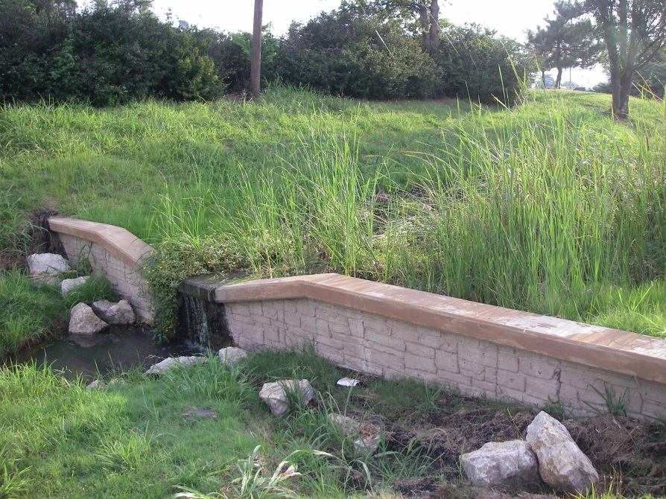
Facility (Open Channel)
0 = Good condition. Well maintained, no action required.
1 = Moderate condition. Adequately maintained, routine maintenance needed.
2 = Degraded condition. Poorly maintained, routine maintenance and repair needed.
3 = Serious condition. Immediate need for repair or replacement.
Concern | Rating | Comments
Maintenance access to channel | 0 1 2 3 NA
Sediment accumulation | 0 1 2 3 NA
Evidence of oil/chemical accumulation | 0 1 2 3 NA
Evidence of standing water | 0 1 2 3 NA
- Ponding
- Noticeable odors
- Water stains
- Presence of algae or floating aquatic vegetation
Underdrain system (if equipped) | 0 1 2 3 NA
- Broken
- Clogged
Condition of check dams | 0 1 2 3 NA
Vegetation | 0 1 2 3 NA
- Plant composition consistent with approved plans | 0 1 2 3 NA
- Presence of invasive species/weeds | 0 1 2 3 NA
- Dead vegetation/exposed soil | 0 1 2 3 NA

Outlets For Open Channel
0 = Good condition. Well maintained, no action required.
1 = Moderate condition. Adequately maintained, routine maintenance needed.
2 = Degraded condition. Poorly maintained, routine maintenance and repair needed.
3 = Serious condition. Immediate need for repair or replacement.
Concern | Rating | Comments
Outlets provide stable conveyance from the channel | 0 1 2 3 NA
Excessive trash/debris/sediment accumulation at outlet | 0 1 2 3 NA
Evidence of erosion at or around outlet | 0 1 2 3 NA

Miscellaneous (Open Channel)
0 = Good condition. Well maintained, no action required.
1 = Moderate condition. Adequately maintained, routine maintenance needed.
2 = Degraded condition. Poorly maintained, routine maintenance and repair needed.
3 = Serious condition. Immediate need for repair or replacement.
Concern | Rating | Comments
Complaints from local residents | 0 1 2 3 NA
Mosquito proliferation | 0 1 2 3 NA
Encroachment on facility or easement by buildings or other structures | 0 1 2 3 NA

Inspector’s summary (attach photos): ___________________________________________________________________________________________________________________________________________________________________________________________________________________________________________________________________________________________________________________________________________________________________________________________________________________________________________________________________________________________________________________________________________________________________________________________________________________
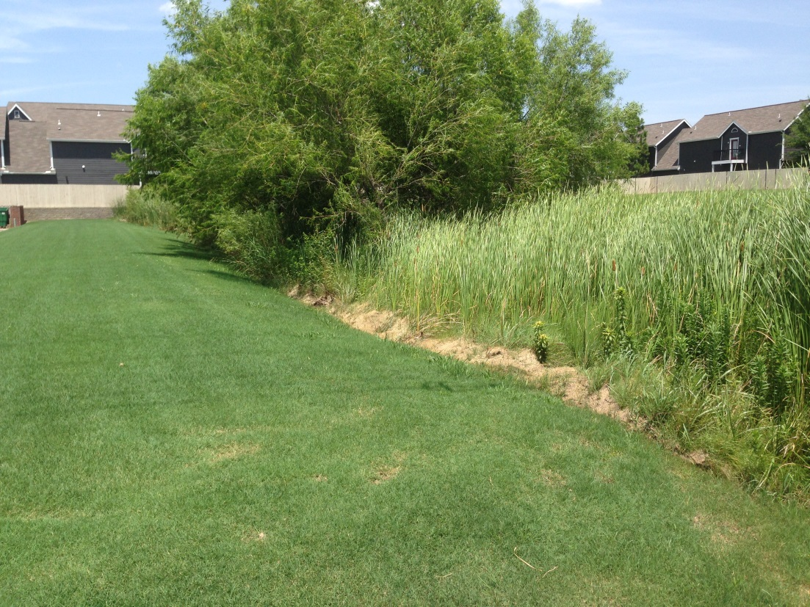

Site Information For Natural Area Conservation and/or Restoration Area
Site ID: |  | Date & Time:
Street Location: | GPS Coordinates:
Inspector Name: | Inspector Title:
Inspector Contact Information:
Phone Number(s): Email:
Mailing Address:
Party Responsible for Maintenance:

Natural Area Conservation and/or Restoration Area Maintenance
Concern | Type | Comments
Type of natural area conservation
- Forest
- Prairie
- Other

Contributing Drainage Area To Natural Area Conservation and/or Restoration Area
0 = Good condition. Well maintained, no action required.
1 = Moderate condition. Adequately maintained, routine maintenance needed.
2 = Degraded condition. Poorly maintained, routine maintenance and repair needed.
3 = Serious condition. Immediate need for repair or replacement.
Concerns | Rating | Comments
Excessive trash and debris present | 0 1 2 3 NA
Bare or exposed soil present | 0 1 2 3 NA
Evidence of erosion | 0 1 2 3 NA
Excessive landscape waste and yard clippings | 0 1 2 3 NA
Impervious area added | 0 1 2 3 NA
Evidence of excessive fertilization or yard chemicals | 0 1 2 3 NA

Facility (Natural Area and/or Restoration Area)
0 = Good condition. Well maintained, no action required.
1 = Moderate condition. Adequately maintained, routine maintenance needed.
2 = Degraded condition. Poorly maintained, routine maintenance and repair needed.
3 = Serious condition. Immediate need for repair or replacement.
Concern | Rating | Comments
Maintenance access to area | 0 1 2 3 NA
Conservation area signs | 0 1 2 3 NA
Evidence of erosion | 0 1 2 3 NA
Evidence of oil/chemical accumulation | 0 1 2 3 NA
Vegetation
- Disturbance to natural vegetation (e.g. mowing, tree cutting) | 0 1 2 3 NA
- Presence of invasive species/weeds | 0 1 2 3 NA
- Dead vegetation/exposed soil | 0 1 2 3 NA
- Restoration planting survival, if applicable | 0 1 2 3 NA

Miscellaneous (Natural Area and/or Restoration Area)
0 = Good condition. Well maintained, no action required.
1 = Moderate condition. Adequately maintained, routine maintenance needed.
2 = Degraded condition. Poorly maintained, routine maintenance and repair needed.
3 = Serious condition. Immediate need for repair or replacement.
Concern | Rating | Comments
Complaints from local residents | 0 1 2 3 NA
Mosquito proliferation | 0 1 2 3 NA
Encroachment on facility or easement by buildings or other structures | 0 1 2 3 NA

Inspector’s summary (attach photos): ___________________________________________________________________________________________________________________________________________________________________________________________________________________________________________________________________________________________________________________________________________________________________________________________________________________________________________________________________________________________________________________________________________________________________________________________________________________

Site Information For Buffer Areas
Site ID: |  | Date & Time:
Street Location: | GPS Coordinates:
Inspector Name: | Inspector Title:
Inspector Contact Information:
Phone Number(s): Email:
Mailing Address:
Party Responsible for Maintenance:

Buffer Areas
Concern | Type | Comments
Sheet flow drainage area
- All pervious area
- Includes impervious areas
Buffer protects
- Stream
- Lake or pond
- Other
Buffer’s natural condition
- Forest
- Prairie/grassland
- Other
Buffer meets width requirement  Yes No |  | Required buffer width:

Contributing Drainage Area To Buffer Area
0 = Good condition. Well maintained, no action required.
1 = Moderate condition. Adequately maintained, routine maintenance needed.
2 = Degraded condition. Poorly maintained, routine maintenance and repair needed.
3 = Serious condition. Immediate need for repair or replacement.
Concerns | Rating | Comments
Excessive trash and debris present | 0 1 2 3 NA
Bare or exposed soil present | 0 1 2 3 NA
Evidence of erosion | 0 1 2 3 NA
Excessive landscape waste and yard clippings | 0 1 2 3 NA
Impervious area added | 0 1 2 3 NA
Evidence of excessive fertilization or yard chemicals | 0 1 2 3 NA

Inflow Points To Buffer Area
0 = Good condition. Well maintained, no action required.
1 = Moderate condition. Adequately maintained, routine maintenance needed.
2 = Degraded condition. Poorly maintained, routine maintenance and repair needed.
3 = Serious condition. Immediate need for repair or replacement.
Concerns | Rating | Comments
Runoff enters buffer as sheet flow | 0 1 2 3 NA
Level spreader functional, if applicable | 0 1 2 3 NA
Excessive trash/debris/sediment accumulation at inflow points | 0 1 2 3 NA
Evidence of erosion at/around inflow points | 0 1 2 3 NA

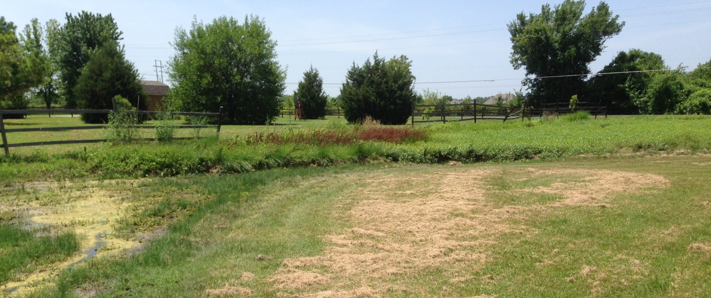
Facility (Buffer Condition)
0 = Good condition. Well maintained, no action required.
1 = Moderate condition. Adequately maintained, routine maintenance needed.
2 = Degraded condition. Poorly maintained, routine maintenance and repair needed.
3 = Serious condition. Immediate need for repair or replacement.
Concern | Rating | Comments
Buffer/conservation area signs | 0 1 2 3 NA
Evidence of erosion | 0 1 2 3 NA
Evidence of oil/chemical accumulation | 0 1 2 3 NA
Vegetation
- Disturbance to natural vegetation (e.g. mowing, tree cutting) | 0 1 2 3 NA
- Presence of invasive species/weeds | 0 1 2 3 NA
- Dead vegetation/exposed soil | 0 1 2 3 NA
- Survival of restoration planting, if applicable | 0 1 2 3 NA
Excessive trash/debris/sediment accumulation in buffer | 0 1 2 3 NA

Miscellaneous
0 = Good condition. Well maintained, no action required.
1 = Moderate condition. Adequately maintained, routine maintenance needed.
2 = Degraded condition. Poorly maintained, routine maintenance and repair needed.
3 = Serious condition. Immediate need for repair or replacement.
Concern | Rating | Comments
Complaints from local residents | 0 1 2 3 NA
Mosquito proliferation | 0 1 2 3 NA
Encroachment on facility or easement by buildings or other structures | 0 1 2 3 NA

Inspector’s summary (attach photos): ___________________________________________________________________________________________________________________________________________________________________________________________________________________________________________________________________________________________________________________________________________________________________________________________________________________________________________________________________________________________________________________________________________________________________________________________________________________

Site Information For Impervious Area Disconnection
Site ID: |  | Date & Time:
Street Location: | GPS Coordinates:
Inspector Name: | Inspector Title:
Inspector Contact Information:
Phone Number(s): Email:
Mailing Address:
Party Responsible for Maintenance:

Impervious Area Disconnection
Concern | Type | Comments
Type of impervious area disconnect
- Rooftop
- Parking
- Other
Compensatory device type (include if pervious area flow path is less than required minimum length)
- Dry well
- French drain
- Raingarden
- Other

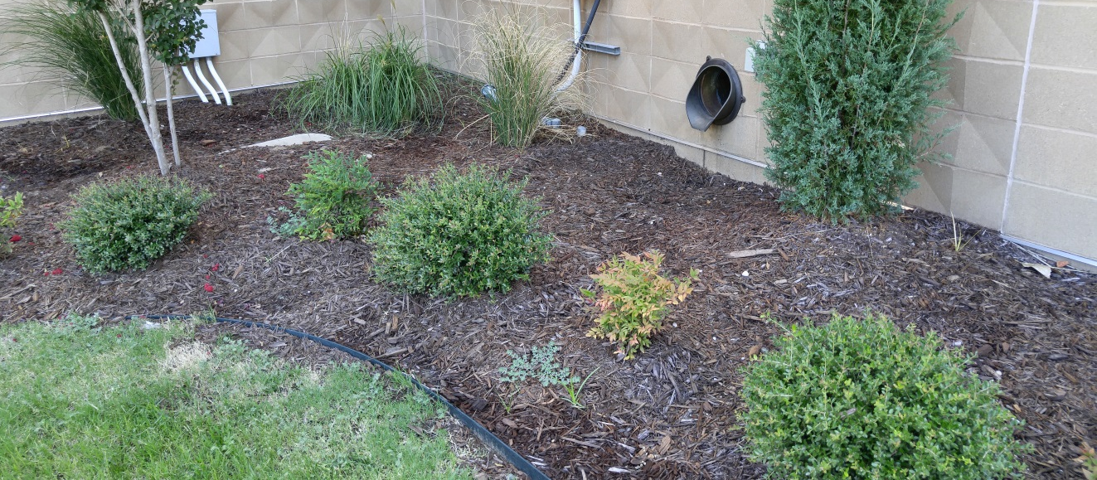
Contributing Drainage Area (Disconnected Impervious Area)
0 = Good condition. Well maintained, no action required.
1 = Moderate condition. Adequately maintained, routine maintenance needed.
2 = Degraded condition. Poorly maintained, routine maintenance and repair needed.
3 = Serious condition. Immediate need for repair or replacement.
Concerns | Rating | Comments
Excessive trash and debris present | 0 1 2 3 NA
Excessive landscape waste and yard clippings | 0 1 2 3 NA

Inflow Points (Disconnected Impervious Area)
0 = Good condition. Well maintained, no action required.
1 = Moderate condition. Adequately maintained, routine maintenance needed.
2 = Degraded condition. Poorly maintained, routine maintenance and repair needed.
3 = Serious condition. Immediate need for repair or replacement.
Concerns | Rating | Comments
Inflow points (e.g. downspouts, curb cuts, edge of pavement, level spreader) provide stable conveyance into facility | 0 1 2 3 NA
Runoff enters pervious areas as sheet flow | 0 1 2 3 NA
Level spreader functional, if applicable | 0 1 2 3 NA
Excessive trash/debris/sediment accumulation at inflow points | 0 1 2 3 NA
Evidence of erosion at/around inflow points | 0 1 2 3 NA

Miscellaneous (Disconnected Impervious Area)
0 = Good condition. Well maintained, no action required.
1 = Moderate condition. Adequately maintained, routine maintenance needed.
2 = Degraded condition. Poorly maintained, routine maintenance and repair needed.
3 = Serious condition. Immediate need for repair or replacement.
Concern | Rating | Comments
Complaints from local residents | 0 1 2 3 NA
Mosquito proliferation | 0 1 2 3 NA
Encroachment on facility or easement by buildings or other structures | 0 1 2 3 NA

Inspector’s summary (attach photos): ___________________________________________________________________________________________________________________________________________________________________________________________________________________________________________________________________________________________________________________________________________________________________________________________________________________________________________________________________________________________________________________________________________________________________________________________________________________

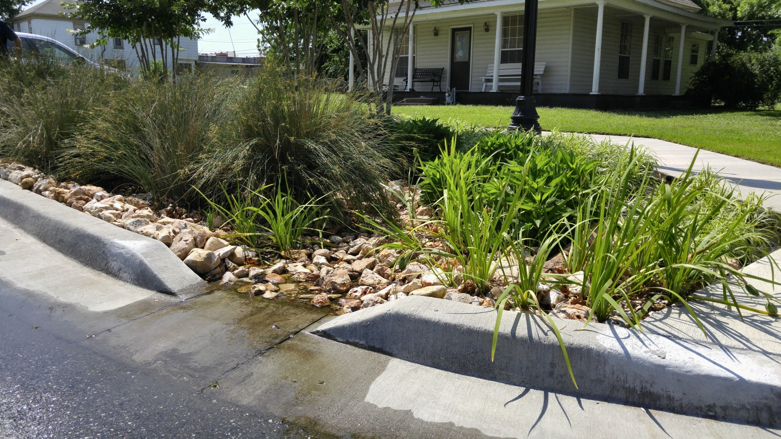

Site Information For Grass Channels and Bioswales
Site ID: |  | Date & Time:
Street Location: | GPS Coordinates:
Inspector Name: | Inspector Title:
Inspector Contact Information:
Phone Number(s): Email:
Mailing Address:
Party Responsible for Maintenance:

Contributing Drainage Area To Grass Channels and Bioswales
0 = Good condition. Well maintained, no action required.
1 = Moderate condition. Adequately maintained, routine maintenance needed.
2 = Degraded condition. Poorly maintained, routine maintenance and repair needed.
3 = Serious condition. Immediate need for repair or replacement.
Concerns | Rating | Comments
Excessive trash and debris present | 0 1 2 3 NA
Bare/exposed soil | 0 1 2 3 NA
Evidence of erosion | 0 1 2 3 NA
Excessive landscape waste and yard clippings | 0 1 2 3 NA
Impervious area added | 0 1 2 3 NA

Inflow Points To Grass Channels and Bioswales
0 = Good condition. Well maintained, no action required.
1 = Moderate condition. Adequately maintained, routine maintenance needed.
2 = Degraded condition. Poorly maintained, routine maintenance and repair needed.
3 = Serious condition. Immediate need for repair or replacement.
Concerns | Rating | Comments
Inflow points (e.g. downspouts, curb cuts, edge of pavement, level spreader) provide stable conveyance into facility | 0 1 2 3 NA
Excessive trash/debris/sediment accumulation at inflow points | 0 1 2 3 NA
Evidence of erosion at/around inflow points | 0 1 2 3 NA

Facility (Grass Channels and Bioswales)
0 = Good condition. Well maintained, no action required.
1 = Moderate condition. Adequately maintained, routine maintenance needed.
2 = Degraded condition. Poorly maintained, routine maintenance and repair needed.
3 = Serious condition. Immediate need for repair or replacement.
Concern | Rating | Comments
Channel remains vegetated, no concrete, rip-rap, or other lining has been added | 0 1 2 3 NA
Grade ensures positive flow | 0 1 2 3 NA
Evidence of erosion | 0 1 2 3 NA
Sediment accumulation | 0 1 2 3 NA
Excessive trash/debris accumulation | 0 1 2 3 NA
Evidence of oil/chemical accumulation | 0 1 2 3 NA
Vegetation condition | 0 1 2 3 NA

Miscellaneous (Grass Channels and Bioswales)
0 = Good condition. Well maintained, no action required.
1 = Moderate condition. Adequately maintained, routine maintenance needed.
2 = Degraded condition. Poorly maintained, routine maintenance and repair needed.
3 = Serious condition. Immediate need for repair or replacement.
Concern | Rating | Comments
Complaints from local residents | 0 1 2 3 NA
Mosquito proliferation | 0 1 2 3 NA
Encroachment on facility or easement by buildings or other structures | 0 1 2 3 NA

Inspector’s summary (attach photos): ___________________________________________________________________________________________________________________________________________________________________________________________________________________________________________________________________________________________________________________________________________________________________________________________________________________________________________________________________________________________________________________________________________________________________________________________________________________

